2021-2022

Hire Package

Treelands Drive Community Centre
&
Wooli St Hall

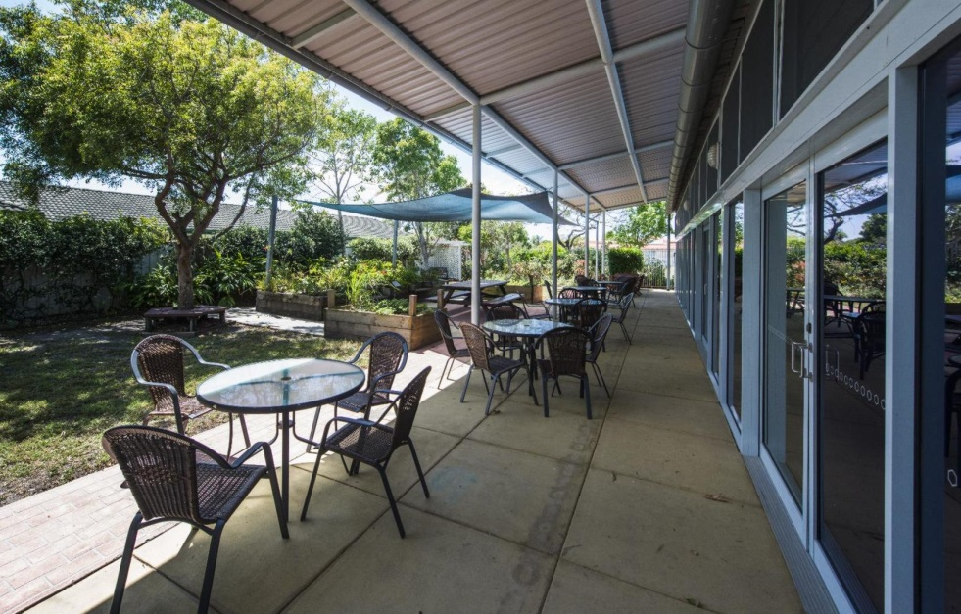

Treelands Drive Community Centre | 24 Treelands Drive, Yamba 2464
Wooli St Hall | 45 Wooli St, Yamba 2464
T 02 6646 1478 | F 02 6646 1897 | E treelandsdrive@clarence.nsw.gov.au

About Us
Treelands Drive Community Centre is the ideal venue for your next conference or meeting.

The Centre offers interview/consult rooms as well as flexible spaces catering for up to 120 guests depending on your room layout. A variety of equipment is available for hire.

The 2 main conference rooms overlook the beautiful established garden courtyard, which makes for great breakout sessions or having morning tea/lunch breaks.

The centre has a fully equipped kitchen as well as kitchenettes in the Session and Meeting Rooms.

The Centre is a hub for providing the community with access to services and resources by offering up-to-date brochures on local and regional community services.

We pride ourselves in being able to provide you with high quality customer service. Business support services such as printing, photocopying, faxing, laminating (charges apply) and free internet services are available at the Centre.

The Centre is fully wheelchair accessible and has an audio hearing loop installed in the Session Room.

Wooli St Hall is located close to Yamba CBD. It consists of 2 areas: a main hall with small stage and sprung wooden floor; and a small downstairs area which overlooks the river and parkland. A small office space with separate entry is also available for hire at the Hall.

Playgroup operates from the back hall. Meals on Wheels operate out of the kitchen just off the main hall.
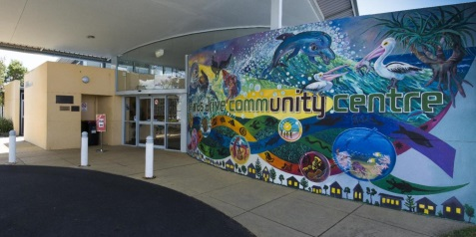

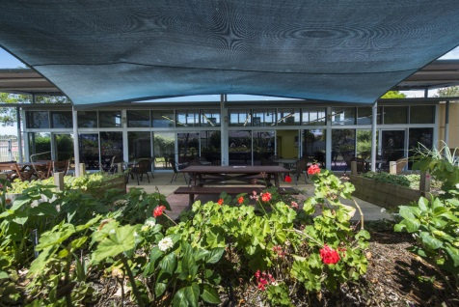

Treelands Drive Community Centre
24 Treelands Drive, Yamba

Wooli St Hall
45 Wooli St, Yamba

T 02 6646 1478
F 02 6646 1897

E treelandsdrive
@clarence.nsw.gov.au

Room Fees & Charges (effective 1 July 2021)
Cat 1 | Commercial entities, including trade union bodies, professional associations, political entities and private hirers where a profit is intended from the event, Government Departments, Instrumentalities and Private Functions (eg Birthday Parties & Weddings)
Cat 2 | Funded Community Groups/Organisations, Unfunded Community Groups/Organisations

TDCC Session Room
 | Cat 1 | Cat 2
Per hr | $41.40 | $12.85
Per 6 hrs | $206.80 | $64.15
Meeting Room
 | Cat 1 | Cat 2
Per hr | $20.20 | $6.15
Per 6 hrs | $100.80 | $30.95
Interview Room
 | Cat 1 | Cat 2
Per hr | $12.85 | $4.00
Per 6 hrs | $64.30 | $19.65
Green Room
 | Cat 1 | Cat 2
Per hr | $20.20 | $6.15
Per 6 hrs | $100.80 | $30.95
Purple Room
 | Cat 1 | Cat 2
Per hr | $20.20 | $6.15
Per 6 hrs | $100.80 | $30.95
Kitchen
 | Cat 1 | Cat 2
Per hr | $5.55 | $1.60
Per 6 hrs | $27.90 | $7.95

Wooli St Hall (First Floor)
 | Cat 1 | Cat 2
Per hr | $33.45 | $10.20
Per 6 hrs | $166.25 | $50.40
Wooli St Hall (Ground Floor)
 | Cat 1 | Cat 2
Per hr | $9.95 | $3.25
Per 6 hrs | $49.15 | $14.50

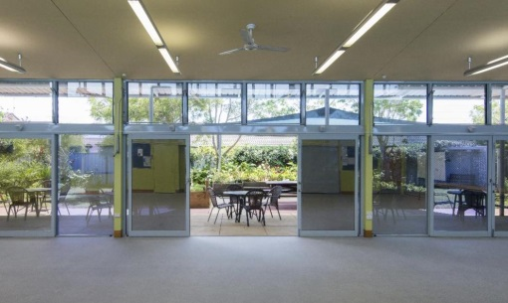

Equipment Charges

Whiteboard
Per hr | $4.00
Per 6 hrs | $19.85
Projector Screen
Per hr | $3.15
Per 6 hrs | $15.40

Laptop
Per hr | $14.30
Per 6 hrs | $71.35

Data Projector
Per hr | $14.30
Per 6 hrs | $71.35
PA System (inc microphone)
Per hr | $4.20
Per 6 hrs | $20.90

Catering
Catering TDCC Only | Per Person
Own Catering using centre’s urn, crockery and cutlery | $0.50
Tea, Coffee, Assorted Biscuits | $4.00

Conditions of Hire – Treelands Drive Community Centre & Wooli St Hall

The Hirer must:
- Be 18 years or over.
- State precisely the type of activity to take place in the Centre.
- Adhere strictly to the hiring hours.
- Under no circumstances enter any areas other than the area hired and common areas.
- Recognise the multi-use aspect of the Centre and the necessary sharing of facilities.
- Ensure their activities do not affect the safety of or intrude on other centre users, staff and surrounding residents.
- Immediately inform the centre coordinator of any safety issues or identified hazards.
- Not tamper with any device or system designed for use in an emergency such as fire extinguishers or fire hose reels.
- Ensure all windows and doors are locked and air conditioners are turned off when leaving the building and where required, the alarm activated.
- Hirers are ultimately responsible for the security of the Centre during their event.
- Hirers are responsible for leaving the area clean and tidy.
Booking Confirmation, Fees and Bond
- Fees are per Clarence Valley Council’s Fees and charges schedules on www.clarence.nsw.gov.au or from the Centres Staff.
- In the case of commercial, social or private events a bond of $285.60 is to be paid at least seven (7) days prior to your event. All bond monies will be refunded in cheque form after the event, provided that all the Conditions of Hire have been met.
- A 20% deposit is required within seven (7) days of booking to secure commercial, social or private events (E.g. Weddings, 18th/21st Birthday party, underage discos or other such events).
- In the case of commercial, social or private events (as listed above) the full hire fee is to be paid at least seven (7) days prior to event.
- Please note that fees and charges are subject to change, generally from the 1 July each year.
- When catering is arranged through the centre, final numbers and options for the catering must be provided at least 3 working days prior to the event.
- Confirmation of your booking is required within 21 days of your enquiry or the tentative booking will lapse.
Cancellation of Booking
- A written cancellation MUST be provided at least four (4) days prior to the event.
- Any cancellations less than four (4) days or not in writing will be charged at the full-agreed fee.
- If a booking is cancelled within 3 working days of the event, all catering options made with the original booking will be charged.
- In exceptional circumstances, and on receipt of a written submission, Council may consider not imposing a room hire cancellation fee for cancellations made within four (4) days of the hire date.
- Any monies due to be refunded will be in cheque form.
Direction from Staff
- The hirer agrees to act in accordance with the Centre staff as directed.
- The Centre reserves the right to require a staff member to be in attendance at events, particularly after hours. An hourly fee for staff will be charged to the hirer accordingly.
Access to the Centre
- Centre staff are generally in attendance Monday to Friday from 8.30am to 5.00pm.
- The centre and hall are available for use 7 days a week, between 07.30am and midnight.
- The set up and removal of all Hirers goods, materials and equipment are to be carried out within the booked times, unless alternate arrangements have been discussed with the Centre Officer prior to the event.
- The premises must be vacated and secured by all patrons within fifteen (15) minutes of the expiration of the booking time and left in a clean state.
- Persons arriving prior to the booked time or before the authorised hirer may be refused access to the Centre and its facilities.
- Kitchens have been designed for limited food preparation; it is recommended that caterers inspect kitchen facilities before the event.
- The kitchen and equipment used is to be thoroughly cleaned after use. This includes the removal of all unconsumed food and drinks from the cool room and refrigerator within the booked times unless alternate arrangements have been discussed with the Centre Officer prior to the event.

Conduct
- The hirer is responsible for the conduct and safety of each and every person in attendance at the event and for the maintenance and preservation of goodwill generally. Should it become necessary for the hirer to leave the facility during the event he or she must nominate a responsible person to act on his or her behalf.
- Children must be supervised at all times by the hirer or their nominated representative.
- Council will not tolerate disorderly or offensive behaviour.
Vacation of Premises
- The hirer will be responsible for ensuring that the Centre is vacated by the scheduled times. If the Centre is not vacated by the scheduled time, additional charges will apply.
- Vacation of Premises MUST be no later than 12.00 midnight.
- The hirer is responsible for the behaviour and the quiet departure of guests from the Centre.
- Strictly all music and speaker assisted acoustics must stop by 11.00pm.
Damage and Breakages
- The hirer is responsible for the full replacement costs of any breakages or damages to the building, its fittings and contents, and the surrounding grounds.
- All breakages must be reported to the Centre staff as soon as possible.
- The hirer must advise if the fire extinguishers have been used in anyway. If equipment is used in an irresponsible manner the cost of inspection and replenishing will be charged to your account.
Parking Noise and surrounding residents
- Noise must be no louder than an acceptable level according to law (not exceed background noise level by more than 5dB (A) between 7.30am and 11.00pm. Please respect our neighbours and encourage your guests to leave quietly.
- Limited parking is available in front of the centre. Please respect the use of bays marked for disabled parking.
- Vehicles MUST not obstruct access to driveways.
Building Terms
- No event shall start before 7.00am or continue past 12.00 midnight.
- Tables, chairs and other equipment (as requested) will be available for Hirers. This equipment is NOT to be removed from the allocated hire area.
- Do NOT drag chairs and/or tables across the floors.
- The Centre can provide limited kitchen equipment, crockery, cutlery and utensils for use of hirers. Please respect this privilege and ensure that you thoroughly clean all kitchen equipment, crockery and utensils prior to putting it away following use.
- Kitchen equipment, crockery and/or utensils are NOT to be removed from the allocated hire area without prior agreement with Centre Officer.
- Internal promotion of a course/group is by negotiation. Advertising must not imply or represent that the views of a particular group are those of the Treelands Drive Community Centre or Clarence Valley Council.
- No animals allowed within either venue or their grounds without prior approval of the Centre Officer. Exemptions apply to guide and hearing dogs.
- No bicycles, roller skates, blades, skateboards, football or soccer boots in the building.
- Electrical equipment brought into the centre MUST comply with the relevant Australian Standards. It is the responsibility of the hirer to ensure any privately owned electrical equipment has suitable electrical surge and overload protection.
- Emergency Procedures – Please refer to Fire Equipment and Evacuation plan provided in all rooms. Fire Exit doors must be kept clear at all times.
- There must be no connection of or interference with the electrical installation or any other electrical property without written permission of the Centre Officer.
- The Centre does NOT assume responsibility for any belongings left or damaged at the centre.
Cleaning
- Preparation of food is only allowed in designated kitchen areas. Please use hand basin in kitchens for washing hands.
- No food or drink should be left in the rooms.
- Rubbish to be disposed in bins provided in rooms.
- A cleaning fee (as per adopted Fees and Charges) may be incurred if the hired areas are not left in a satisfactory condition as determined by the Centre Coordinator.

Security
- Where the event is a social or private event, the Hirer is to arrange and pay for their own security guards at a ratio of 1:50; however the first guard must be hired from the Centre security provider. Additional guards may be used from alternate licensed security providers and must hold a current security licence. All additional guards must provide a copy of their current security licence to the Centre Officer at least seven (7) days prior to the event.
- The Centre is electronically monitored. Do NOT attempt to open doors or enter areas that you have not hired. Any unauthorised entry by hirer or guests into areas not hired will result in alarms being activated and a response from the Centre Security Officers.
- The hirer will be charged for any callout fees caused by unauthorised access.
- Hirers may also be required to arm and disarm the Centre security alarm when using the facility out of normal operating hours. Collection of security access, alarm code, instructions and training must take place no later than 4.30pm on the last working day prior to your event, unless otherwise negotiated.
- The Community Centre features a 24-hour remote monitoring security system, comprising of alarms and constant surveillance by security patrols.
- Fire/Police/Ambulance emergencies dial 000.
- After hours/Emergency Contact (Numbers to be used for after-hours problems or emergency only)
- Advanced Coast Security – 1300 130 618
- Clarence Valley Council Emergency Contact – 0431 201 168
Alcohol/Smoking/Drugs
- Alcohol must not be brought into the premises without a prior consent of the Centre Officer.
- If consent is given, the hirer is responsible to pay for security guards at a ratio of 2:100 guests.
- Also if alcohol is to be sold or an admission/entry fee is charged for the event the hirer must obtain a liquor licence and a copy provided to the Centre Officer at least 48 hours prior to the event.
- The Hirer is responsible for ensuring the responsible service and consumption of alcohol at the event, including ensuring persons under the age of 18 are prohibited from obtaining or consuming alcohol. The hirer will ensure liquor is not carried away by guests or consumed by guests outside the centre.
- No illicit drugs are permitted on premises.
- Both Venues are non-smoking environments, this includes all courtyards and car parking areas.
Decorations and Displays
- Decorations and displays are welcome as long as they are not fastened to the venue using permanent fixtures (nails, screws, pins etc) and will not damage the venue in any way.
- The removal of all decorations is required prior to departure.
- The hirer will be accountable for any damage caused to the venues by the placement or removal of decorations.
- No open flames including candles, kerosene or spirit type lamps may be used in any part of the Centre.
Public Liability Insurance
- Clubs, associations, corporations, incorporated bodies or sporting bodies and any other hirer conducting any kind of profit making or commercial activity are required to have public liability insurance in a sum of not less than $10 million. A copy of the hirer’s insurance letter of currency must be provided at the time of booking.
- All other hirers are covered by Council’s Hirer’s Insurance.
Risk Assessment

- Organisers of certain events may be required to undertake a risk assessment prior to approval being granted to the hirer. Centre staff will advise if the hirer needs to complete a risk assessment tool.

Clarence Valley Council
Reserves the right to:
- Change Conditions of Hire.
- Deny access to any individual or Organisation (its members and/or staff).
- To terminate any agreement, with any individual or organisation, (its members and/or staff) at any time.
- In the event of a dispute or a difference arising as to the interpretation of conditions contained in this agreement, the decision of the General Manager of the Clarence Valley Council shall be final.

Hire Agreement 2021-2022

To confirm your booking, please complete all sections of this form and return to: treelandsdrive@clarence.nsw.gov.au

Hirer Information
Hirer/Group:
Postal Address:
(Account will be sent to this address)
Phone: |  |  |  | Mobile:
Email: |  |  |  | Fax:
ABN: |  |  |  | Own Insurance: |  |  |  | Copy of letter of currency for Public Liability attached
Fee Category  (please indicate, if unsure contact the Centre Staff) | 1 |  | 2

Event Information
Event Name:
Contact Person:  (Person attending the event) |  | Contact Number:
Date of the Event: |  | No of People:
Start Time:  (Including set up time) |  | Finish Time:

Location
Treelands Drive Community Centre
Session Room |  | Meeting Room |  | Interview Room
Purple Room |  | Green Room |  | Kitchen
Glass Room
Wooli St Hall
First Floor (inc Stage) |  | Ground Floor |  | Office

Equipment Required
Whiteboard |  | Laptop |  | Data Projector
Projector Screen |  | Video Conferencing |  | PA System (inc microphone)

Catering (Treelands Drive Community Centre Only)
Use of Centres Urn, crockery & cutlery |  | Tea, Coffee & Biscuits |  | Numbers

Additional Information

Declaration
I have read, understood and agree to adhere to the Treelands Drive Community Centre and Wooli St Hall Conditions of Hire and pay all fees as quoted. ***Signee is responsible for Conditions of Hire***
Name: |  | Signature: |  | Date:
Room Capacity (Maximum Only)
Room | Theatre | Seated Tables
Session Room | 100 | 80
Meeting Room | 26 | 18
Session & Meeting Room (partition opened) | 120 | 100
Purple Room | 6 | n/a
Green Room | 6 | n/a
Interview Room | 3 | n/a

